**Finance Me - Project**

**Banking and Finance Domain**

**FinanceMe has decided to opt for microservice architecture for its applications and decided to go DevOps by implementing necessary automations using CICD. FinanceMe has decided to use AWS as primary cloud services provider to create servers, databases and application deployments.**

**SOLUTIONS:**

* We are going to build 5 servers to complete this project
* Tools usages are explained below

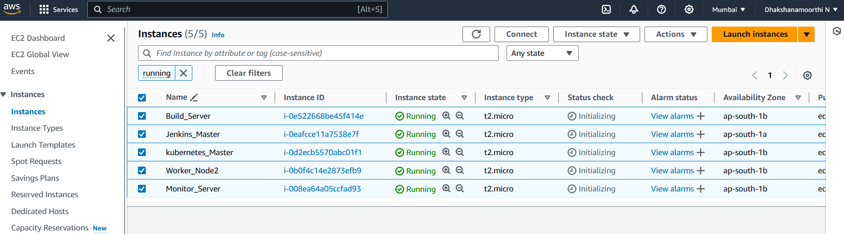

**TOOLS USED in each server :**

* **Eclipse IDE**
* **Jenkins Master** (JDK, Git, Jenkins)
* **Build Server** (JDK,Maven , Git ,Docker)
* **Kubernetes Master** ( Cointainer,Kubectl ,kubeadm ,kubelet)
  + - **Kubernetes WorkerNode**
* **Monitor Server** ( Prometheus and Grafana)

**NOTE : Tool Installation and configuration explained in other document**

**STEP -1:**

**Import our source code repository into Eclipse IDE.**

* Open IDE and select import option and select **import** from Git .
* Select option as **clone** url and copy our git url from our GitHub repository .
* And add our **credentials** which is username and password as our github token access which created from developer setting in github.
* Select Branch and click next

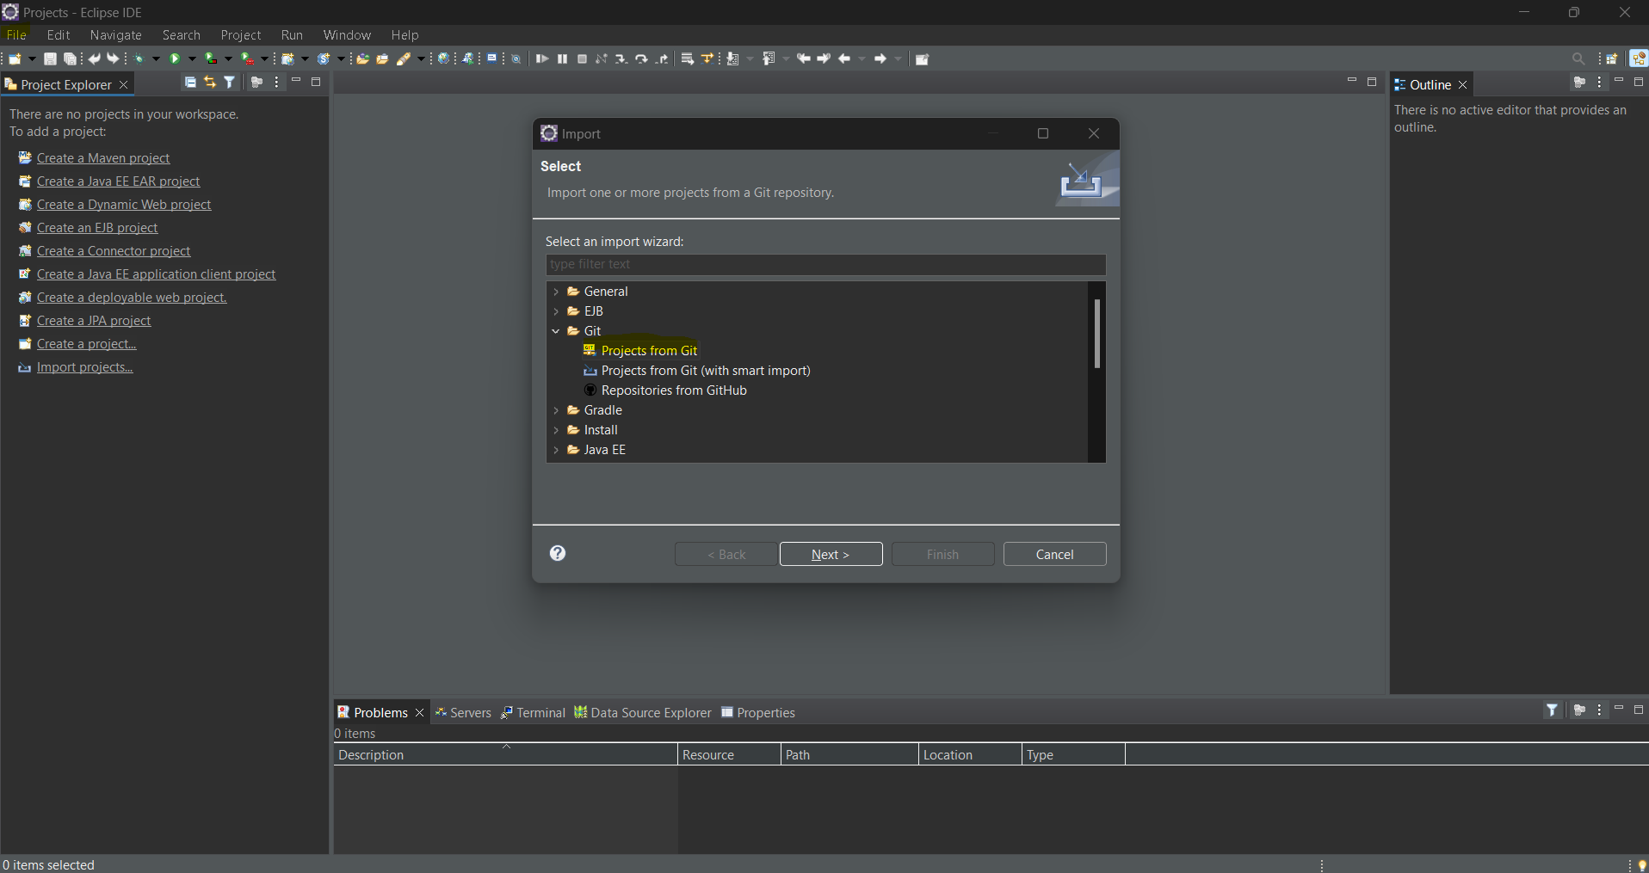

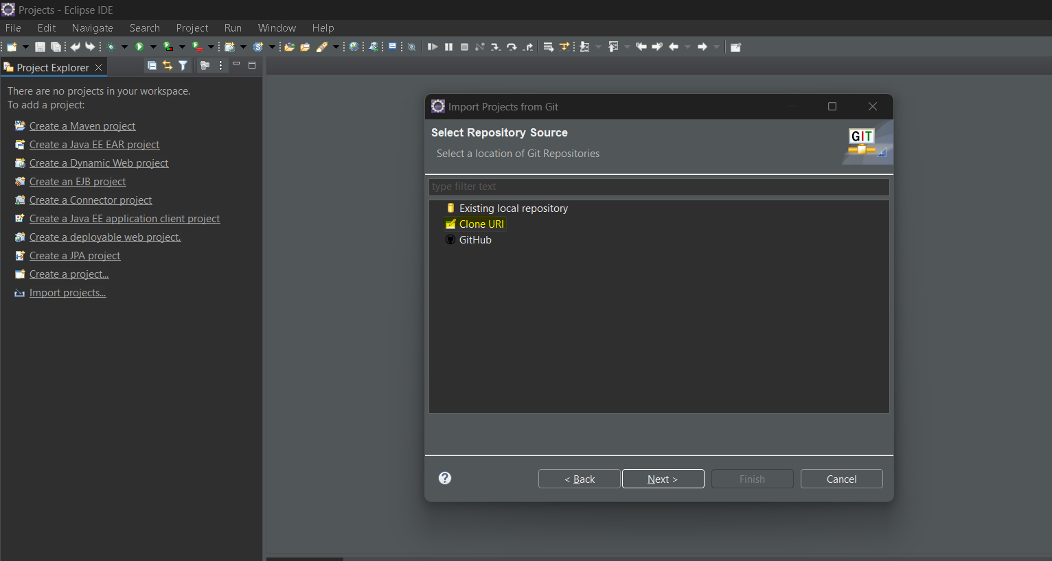

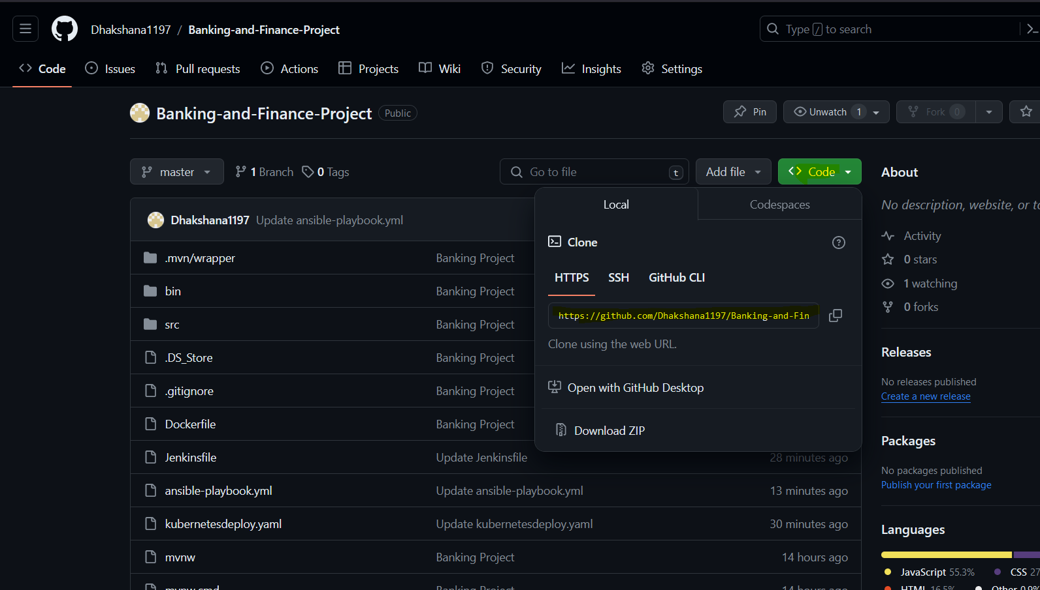

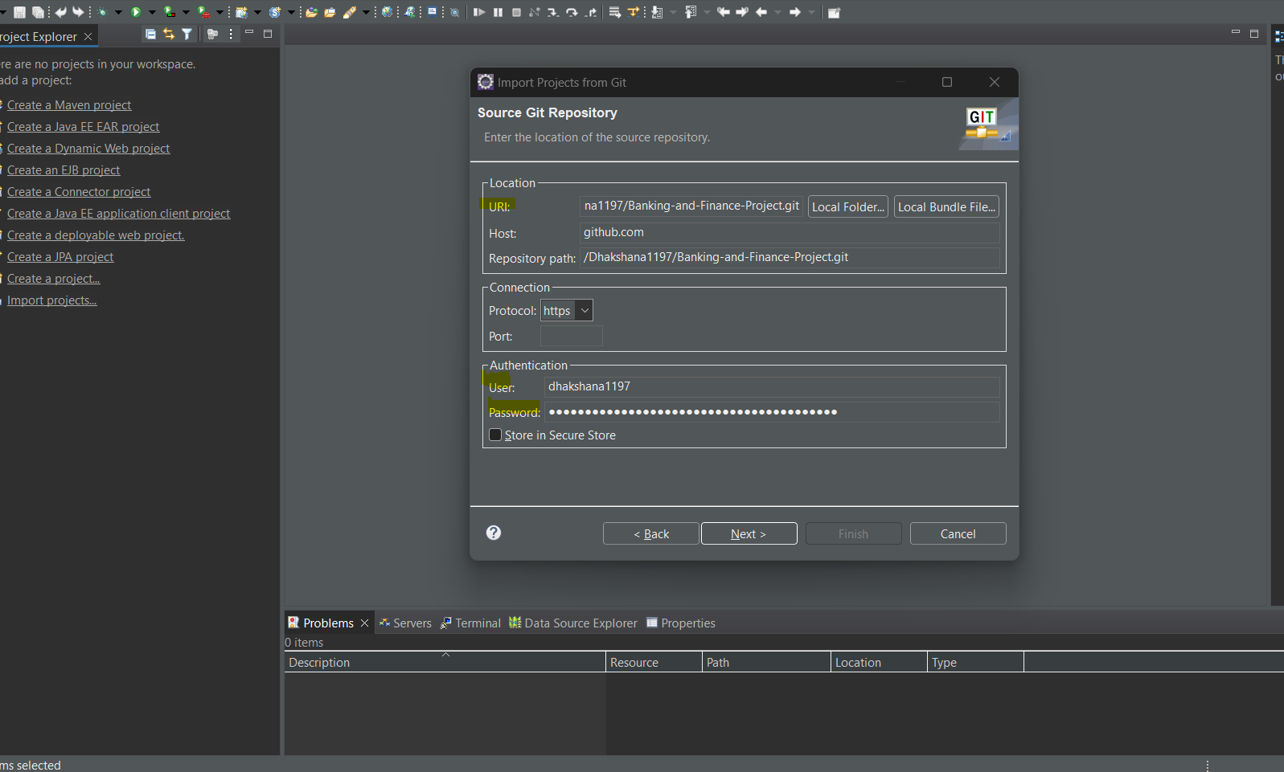

Choose directory and click Next .

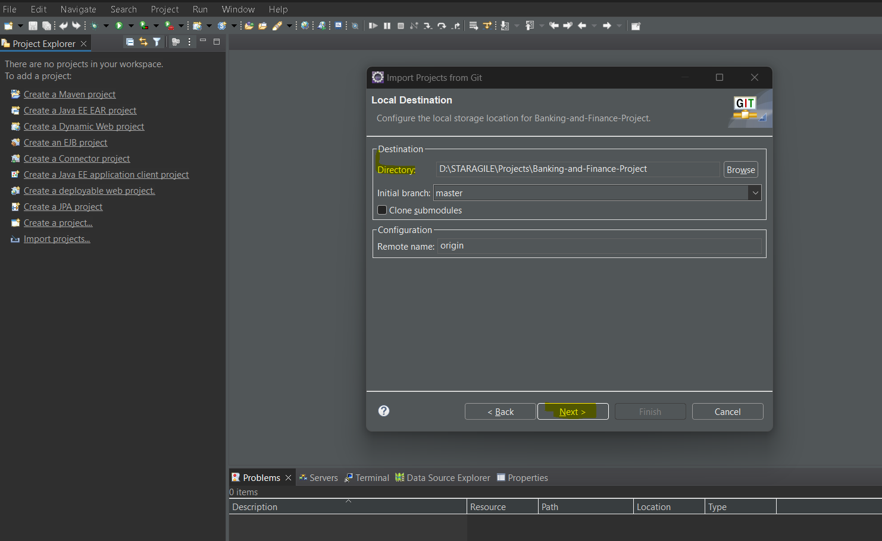

Select as Import as new project and finish.

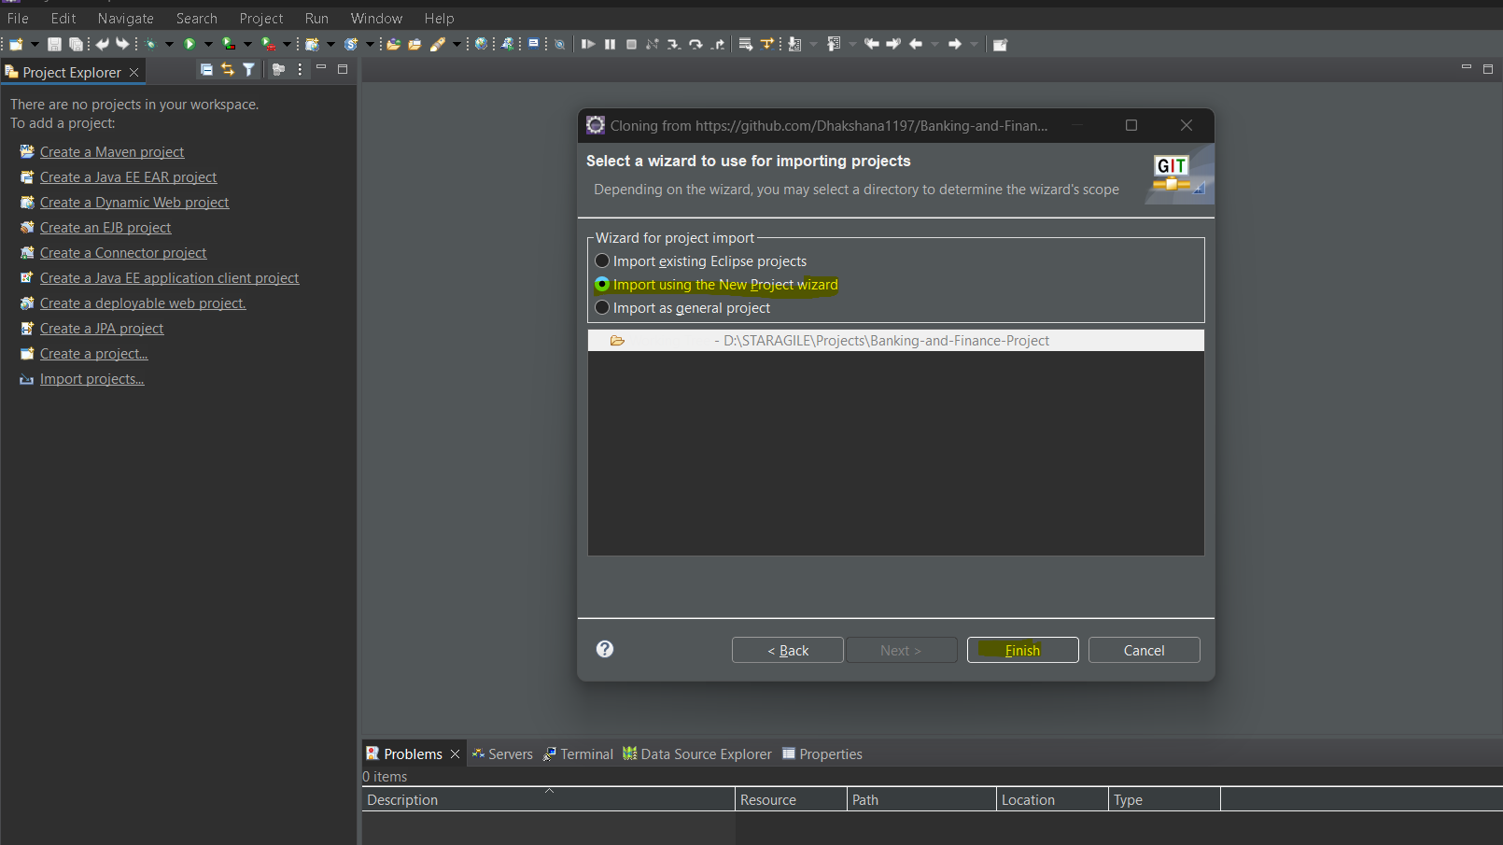

Select File and click open from file system where we cloned our repository into local.

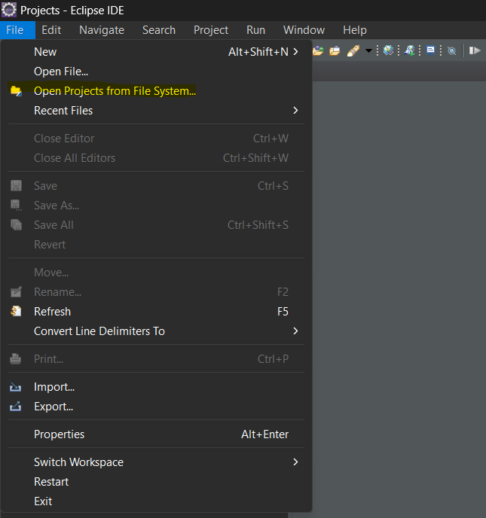

Once imported successfully we have results like below .

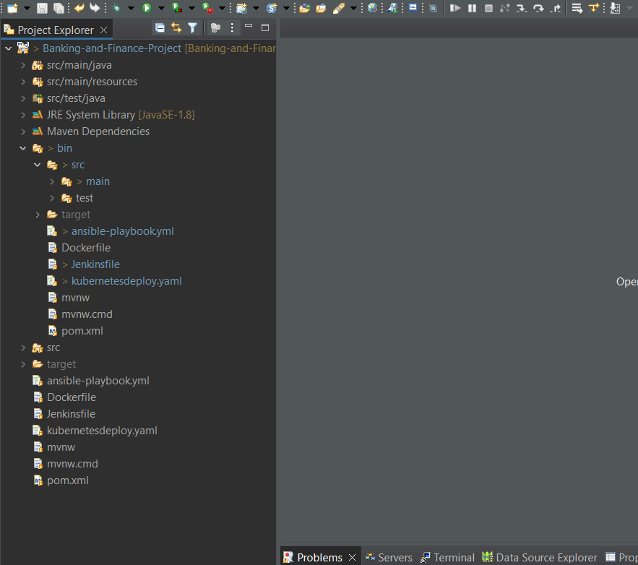

Now we are going to run the project.

* Right click on the project and select run as maven build
* After the write the maven goal to perform.

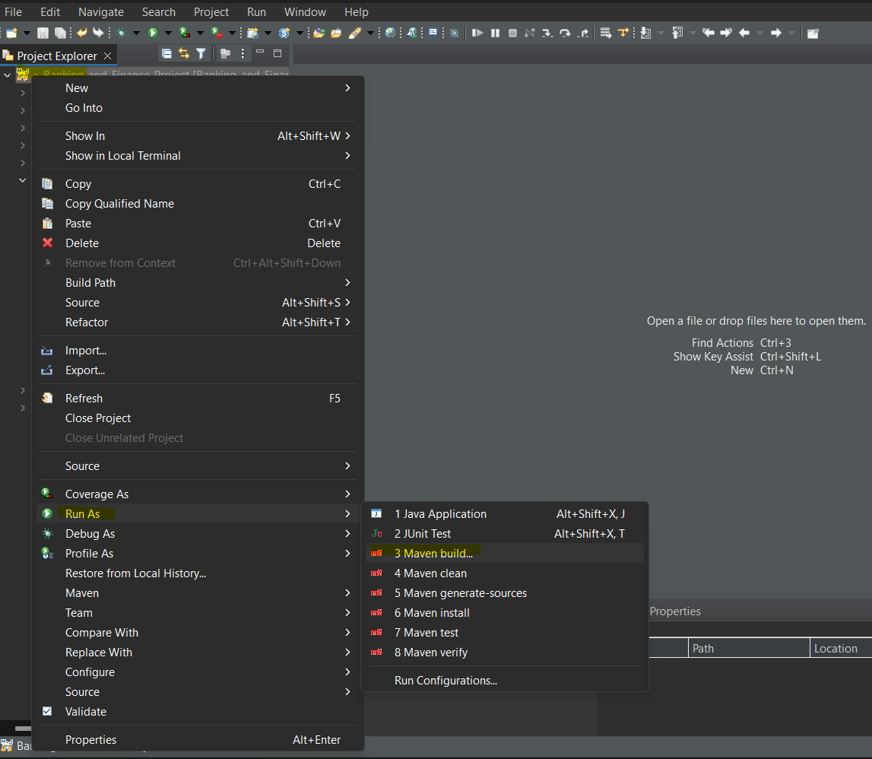

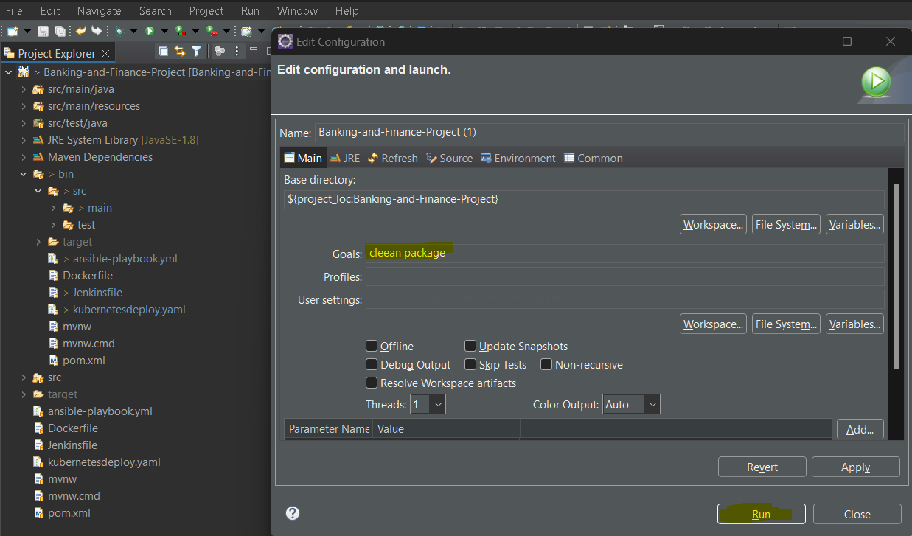

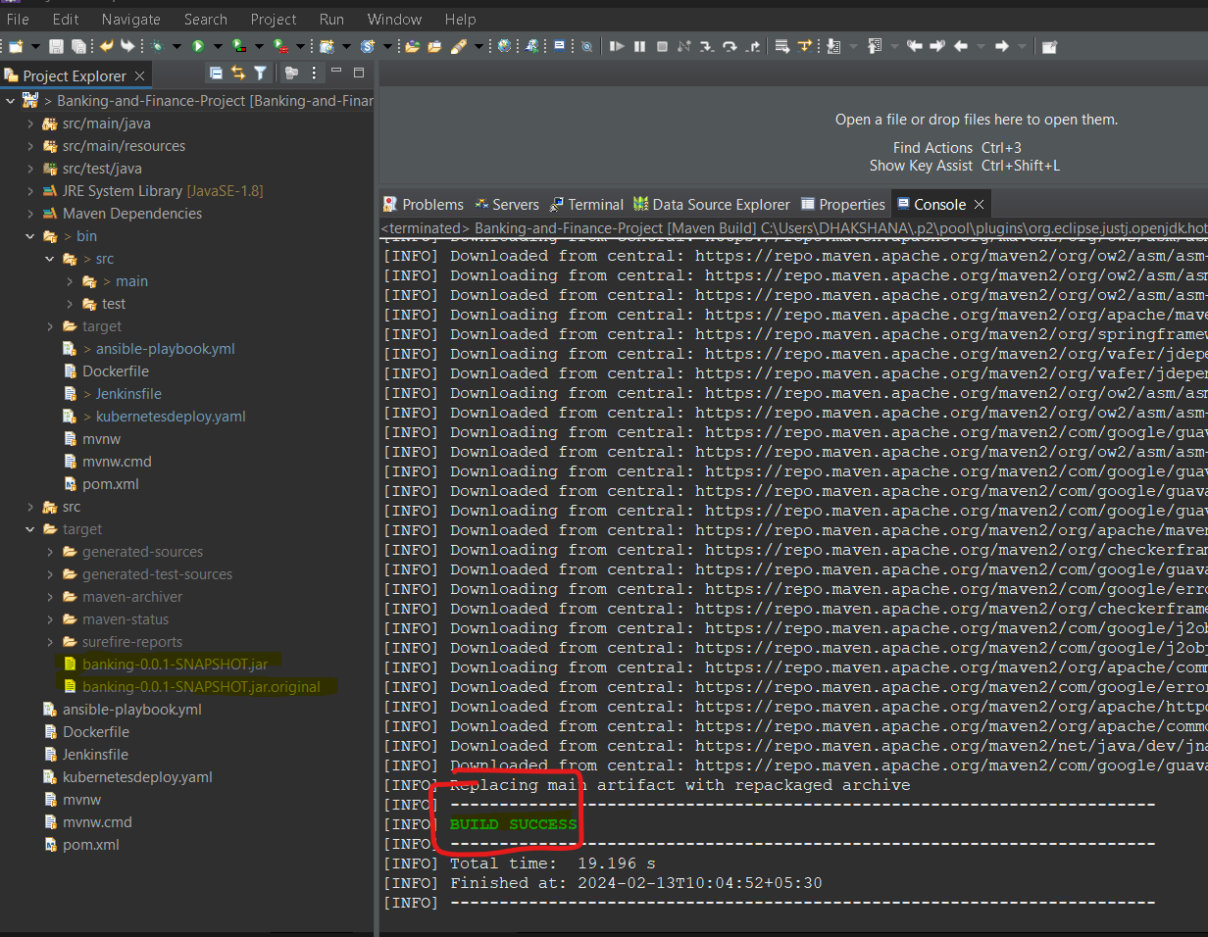Once build completed we can get output.

Now we are going to run our java application .

* Right click on our project and select run as java application .

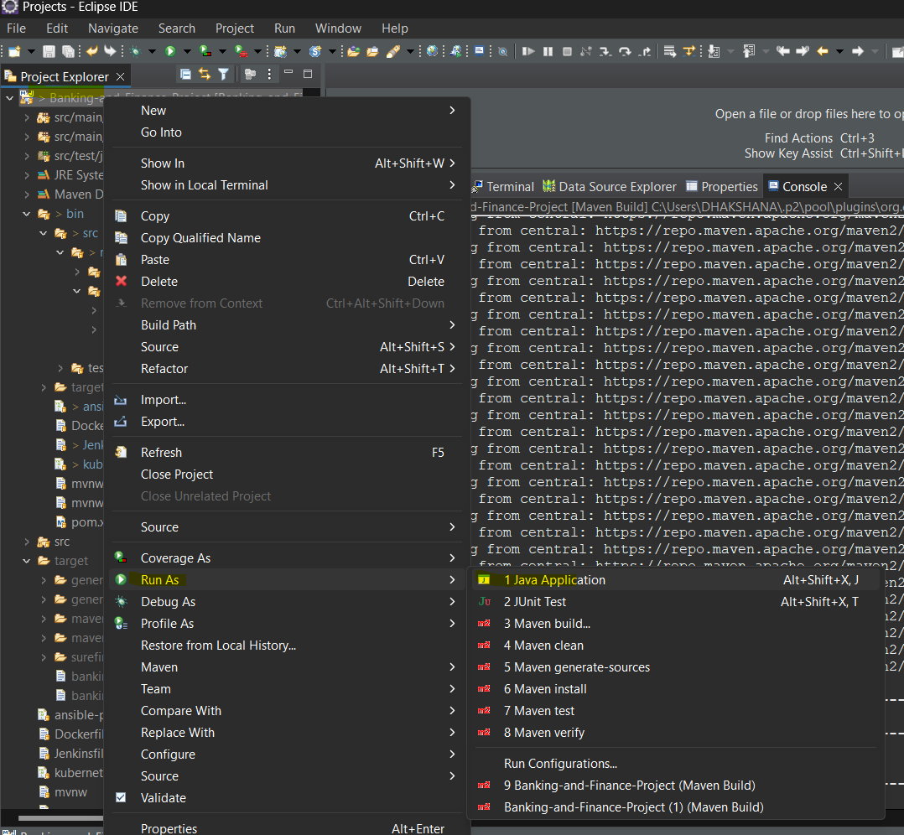

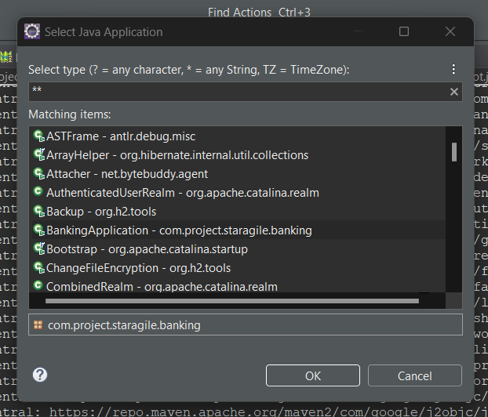

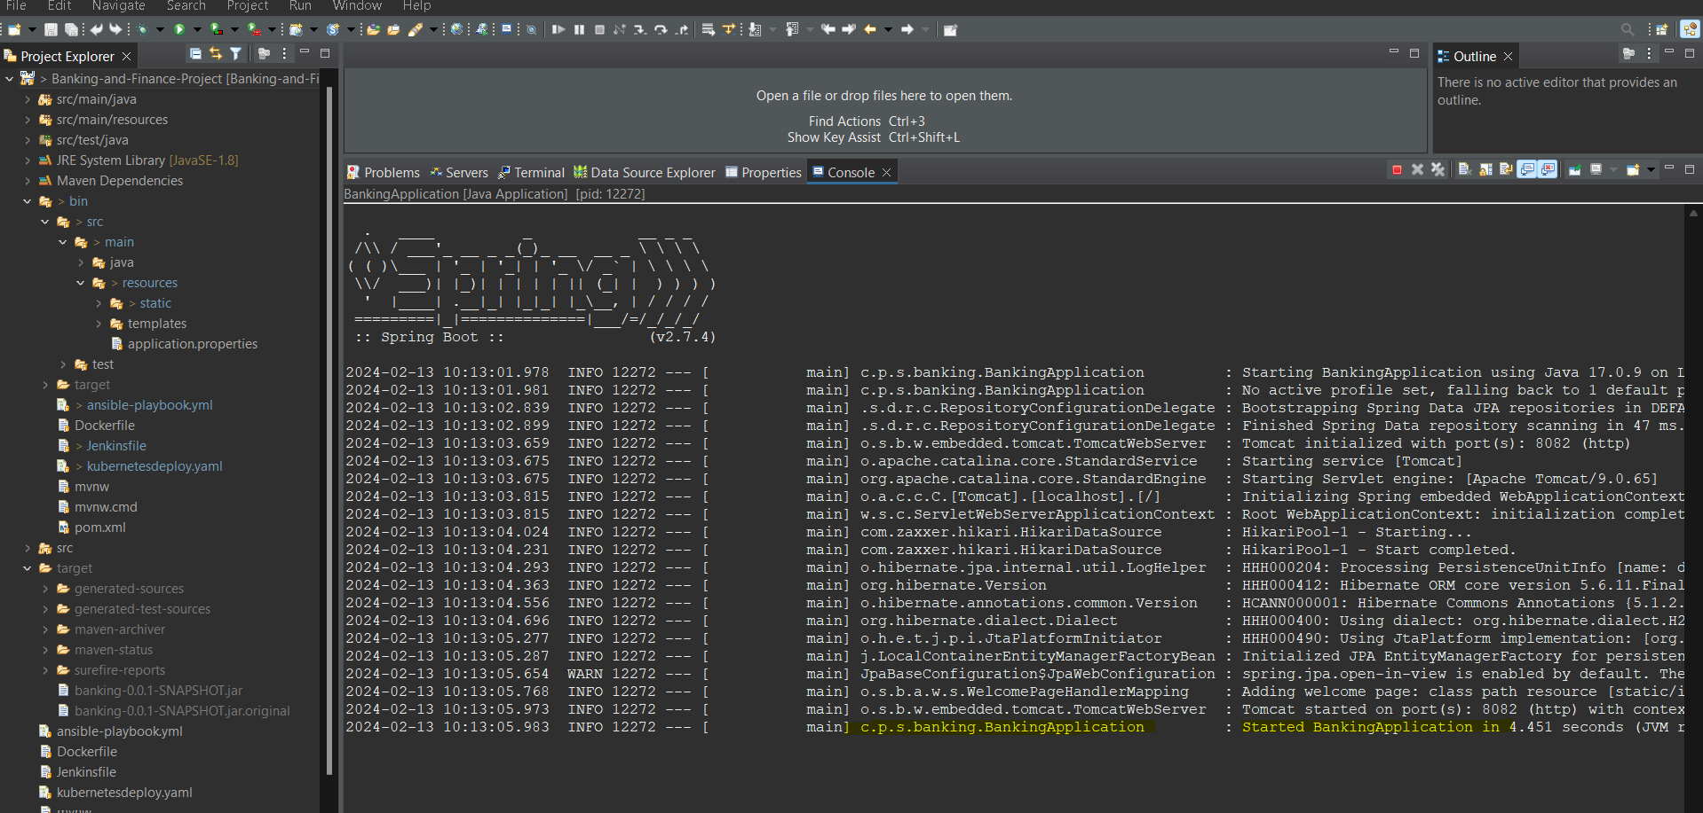Once application started we can get output

We can access through browser by using **localhost:<portnumber>** which we can defined in application properties.

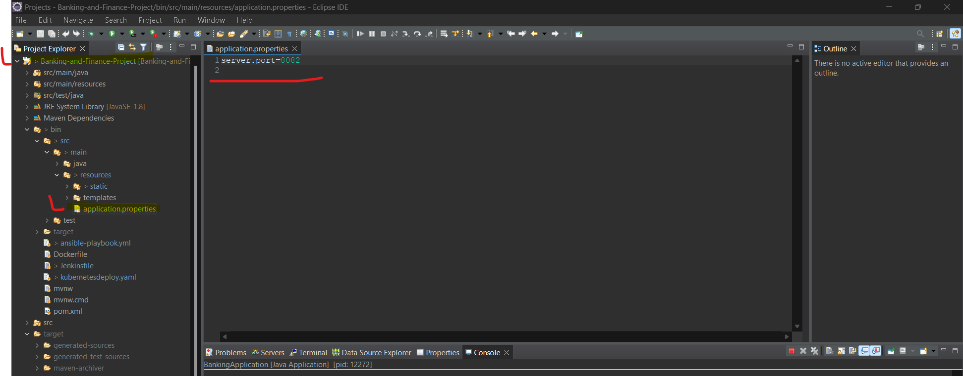

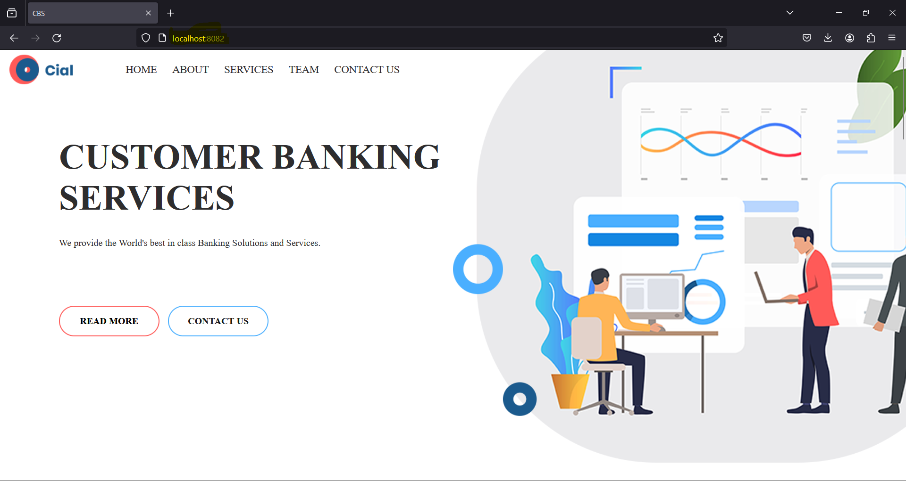

Now we are going to try all of our resources which under resource> static folder .

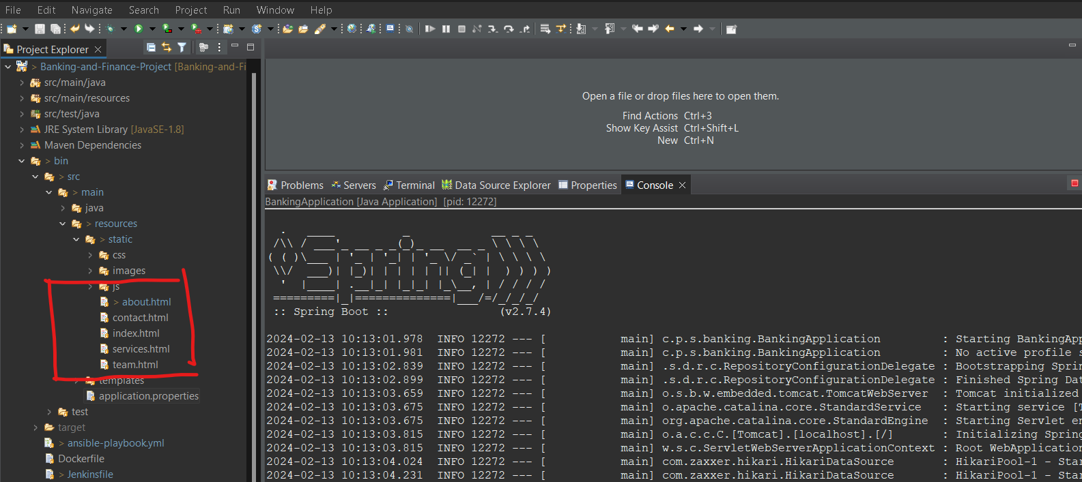

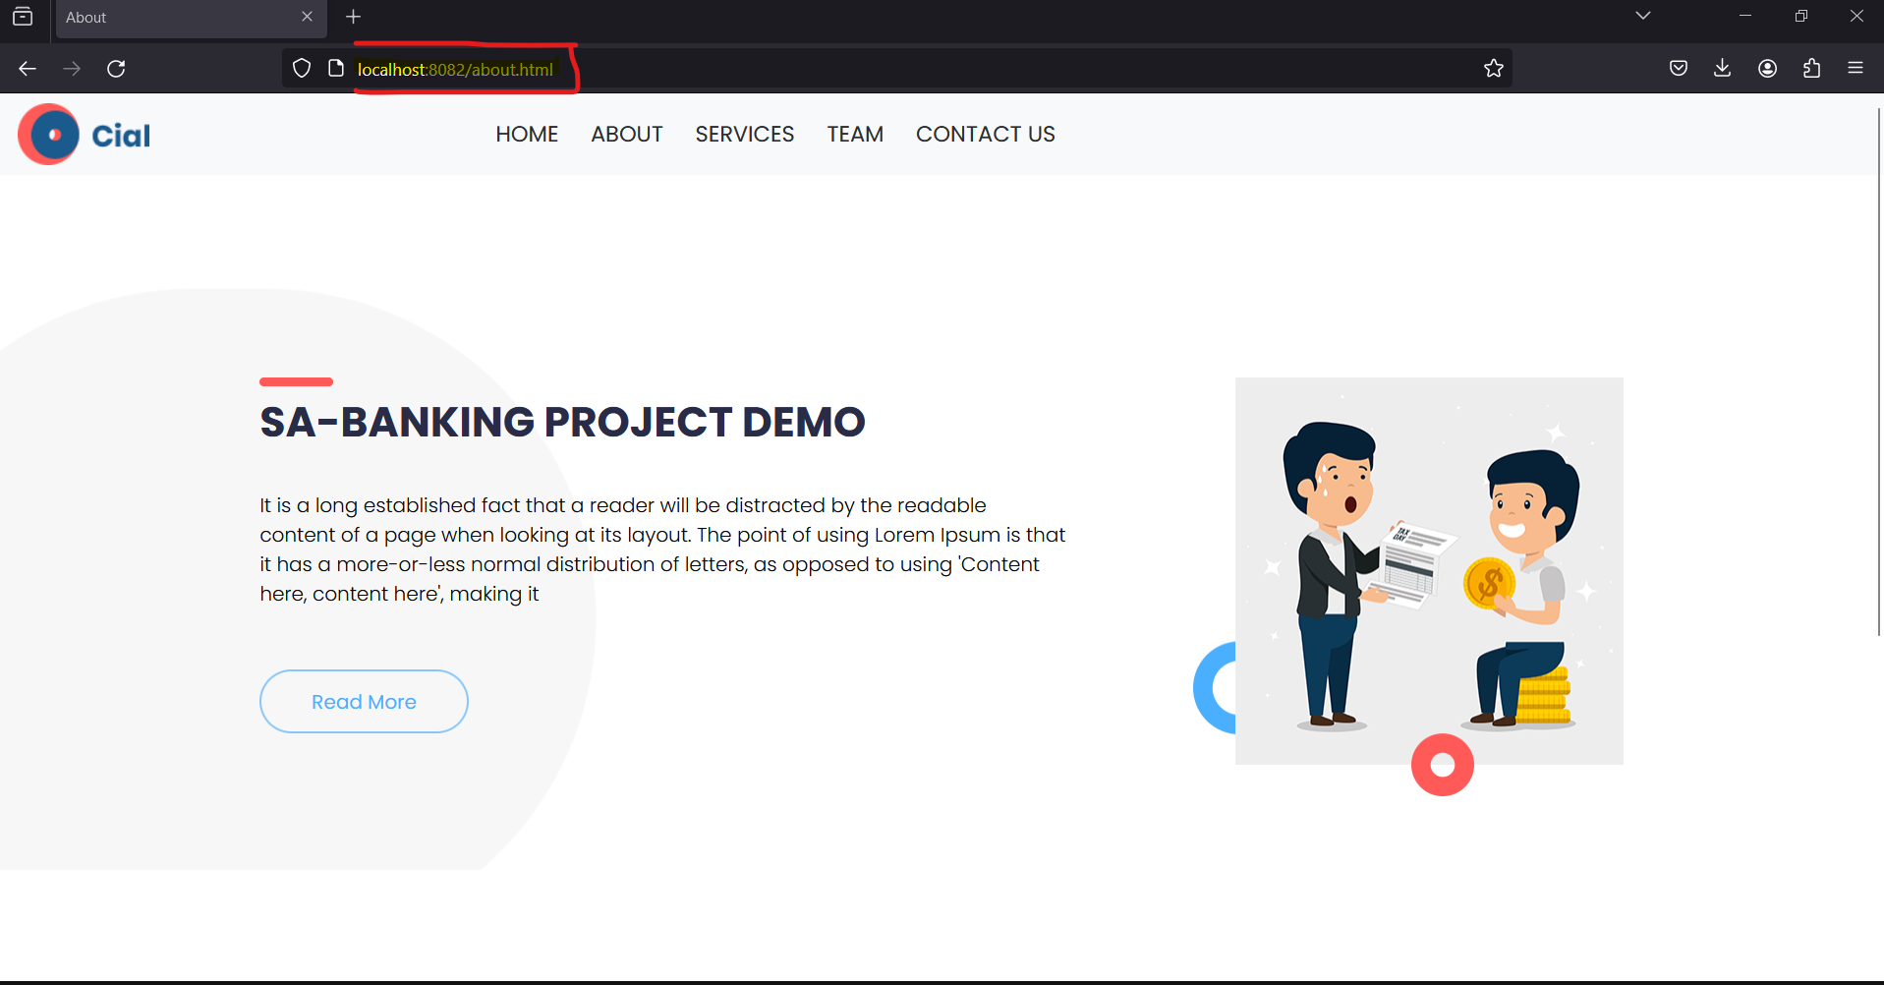

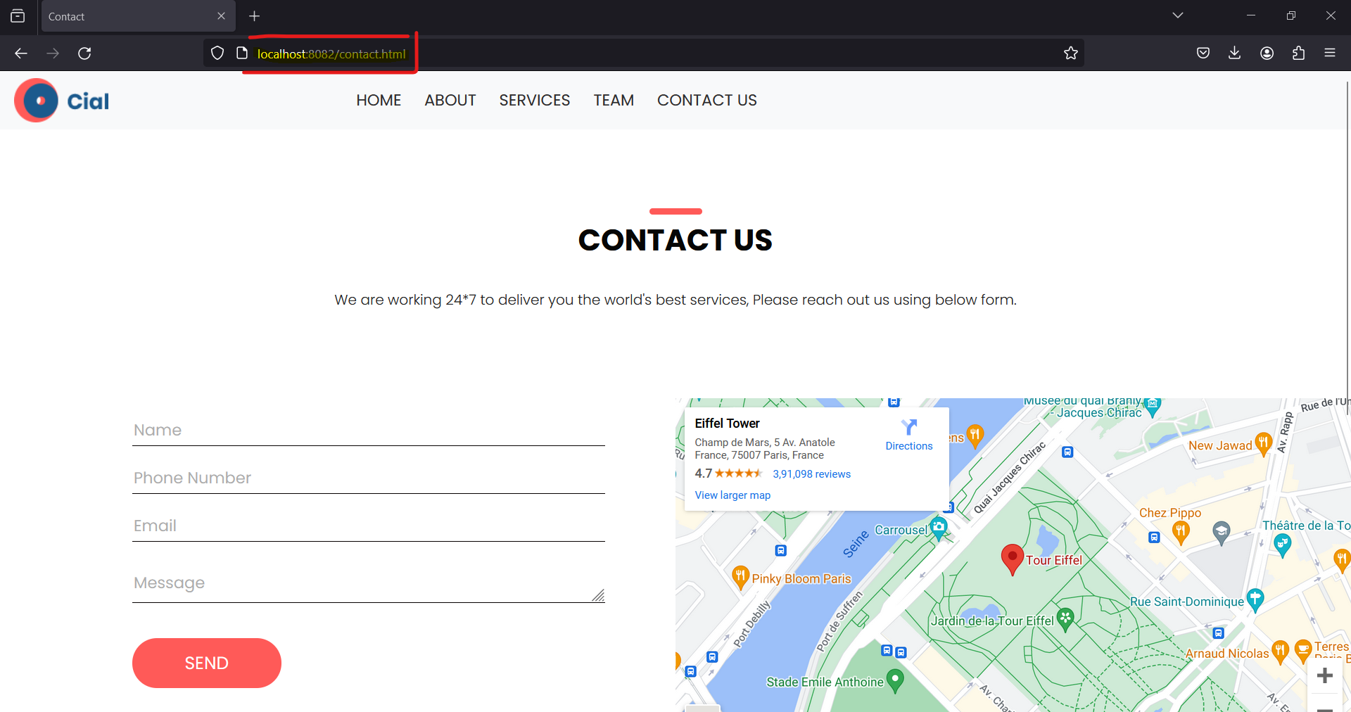

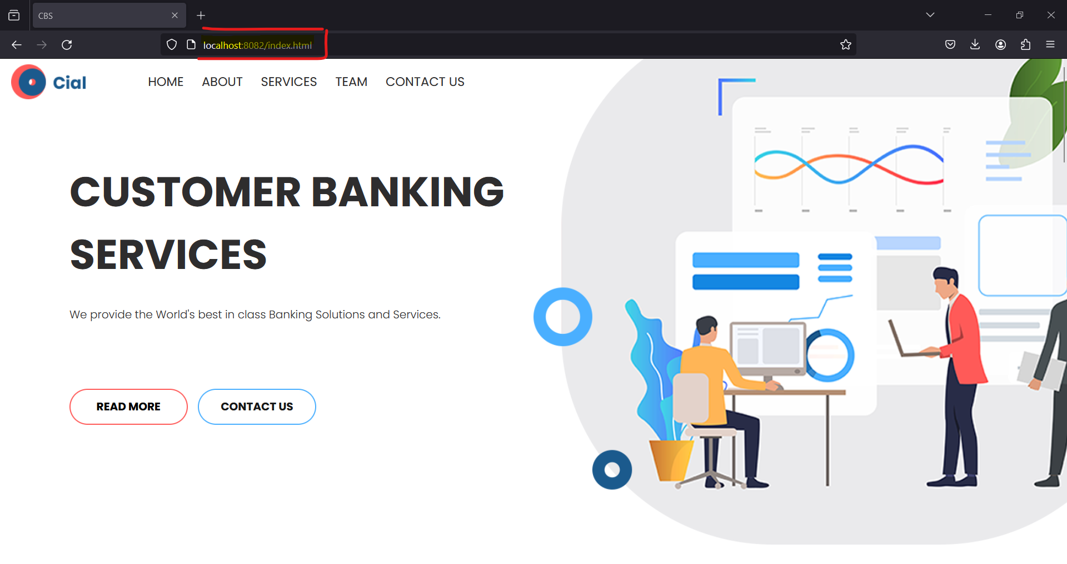

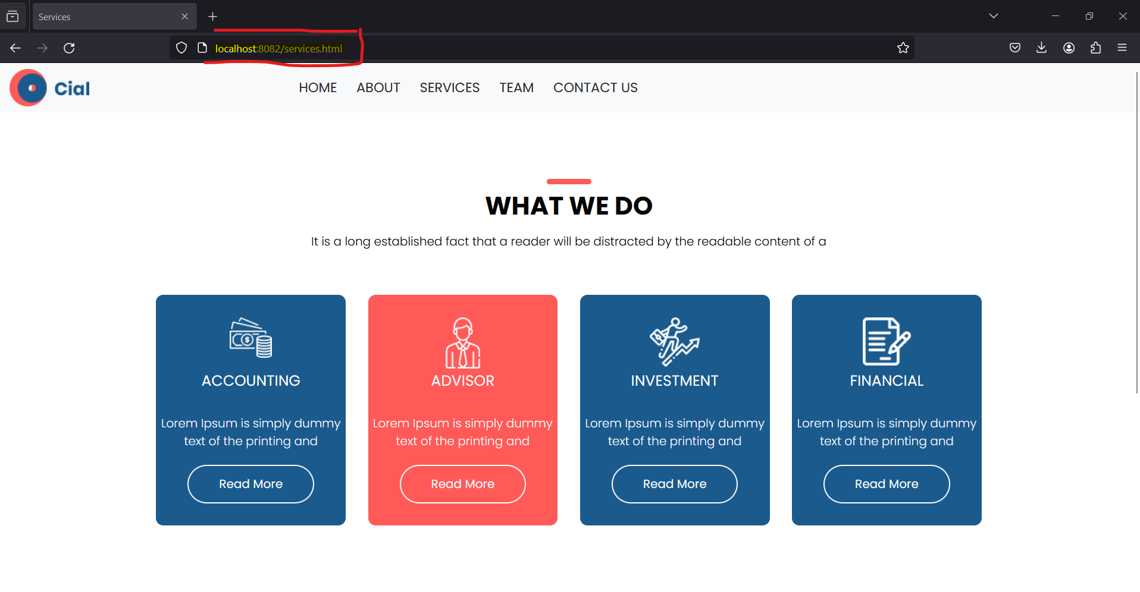

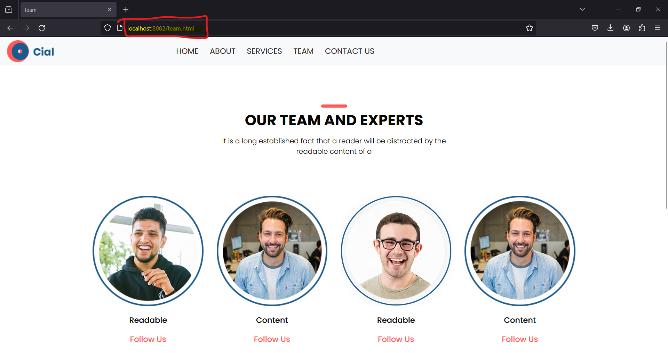

Once Verified successfully we going to commit our project .

* Select file and click team and select commit
* And stage our changes
* And add our commit messages
* And commit and push to our git repository by providing author details
* Provide git url and password which is token access key

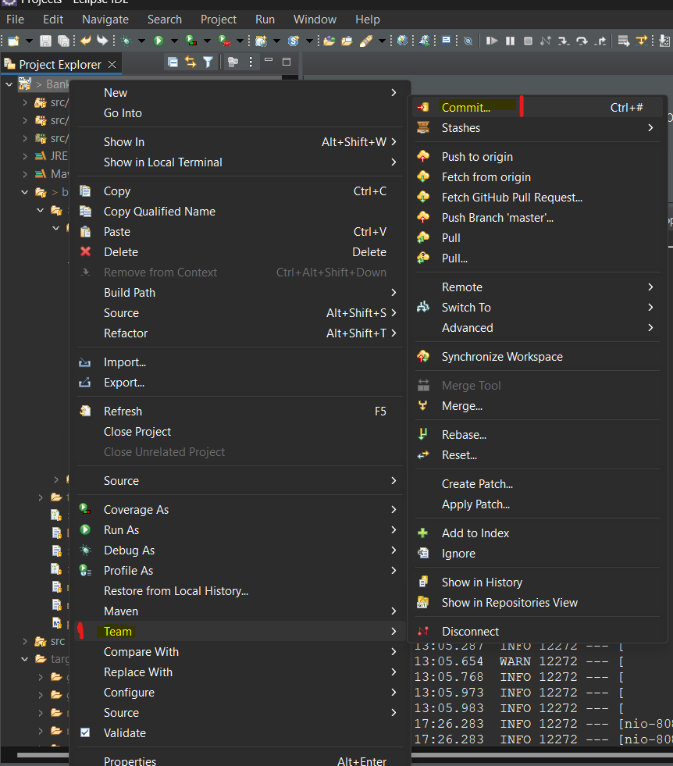

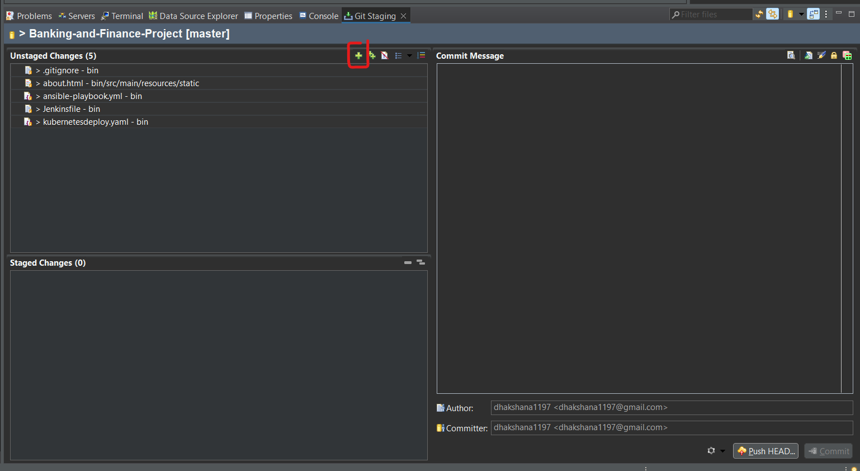

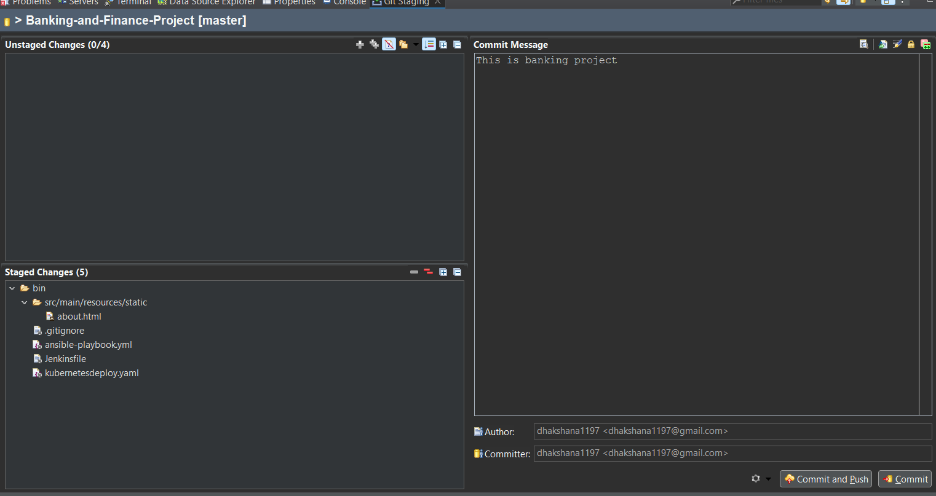

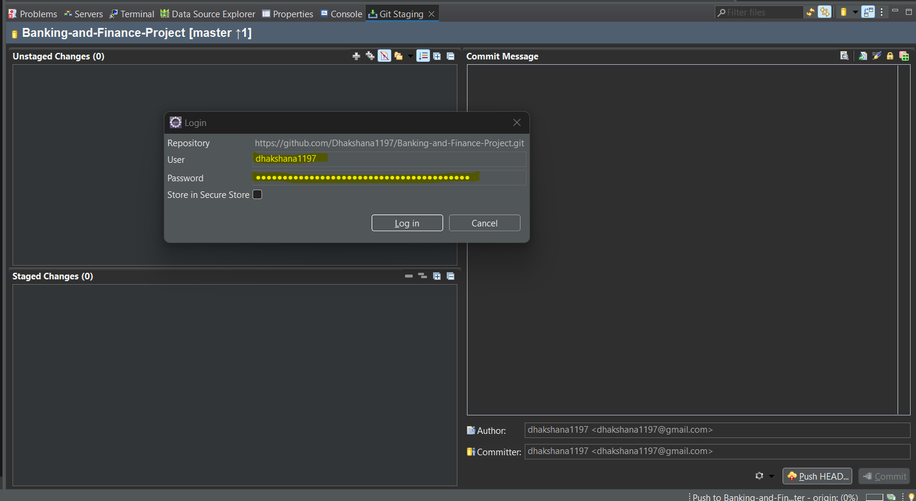

Now we are going to create Jenkins Pipeline in Jenkins master server.

* **Login** to Aws Jenkins master instance and login
* And **create** pipeline project
* Create pipeline **scripts** .
* Once pipeline project created , run the project by using option **build now**
* Verify the console output .
* Verify the all process completed successfully (build images in docker hub , Kubernetes deployment) .
* Deployed application verify through Browser.

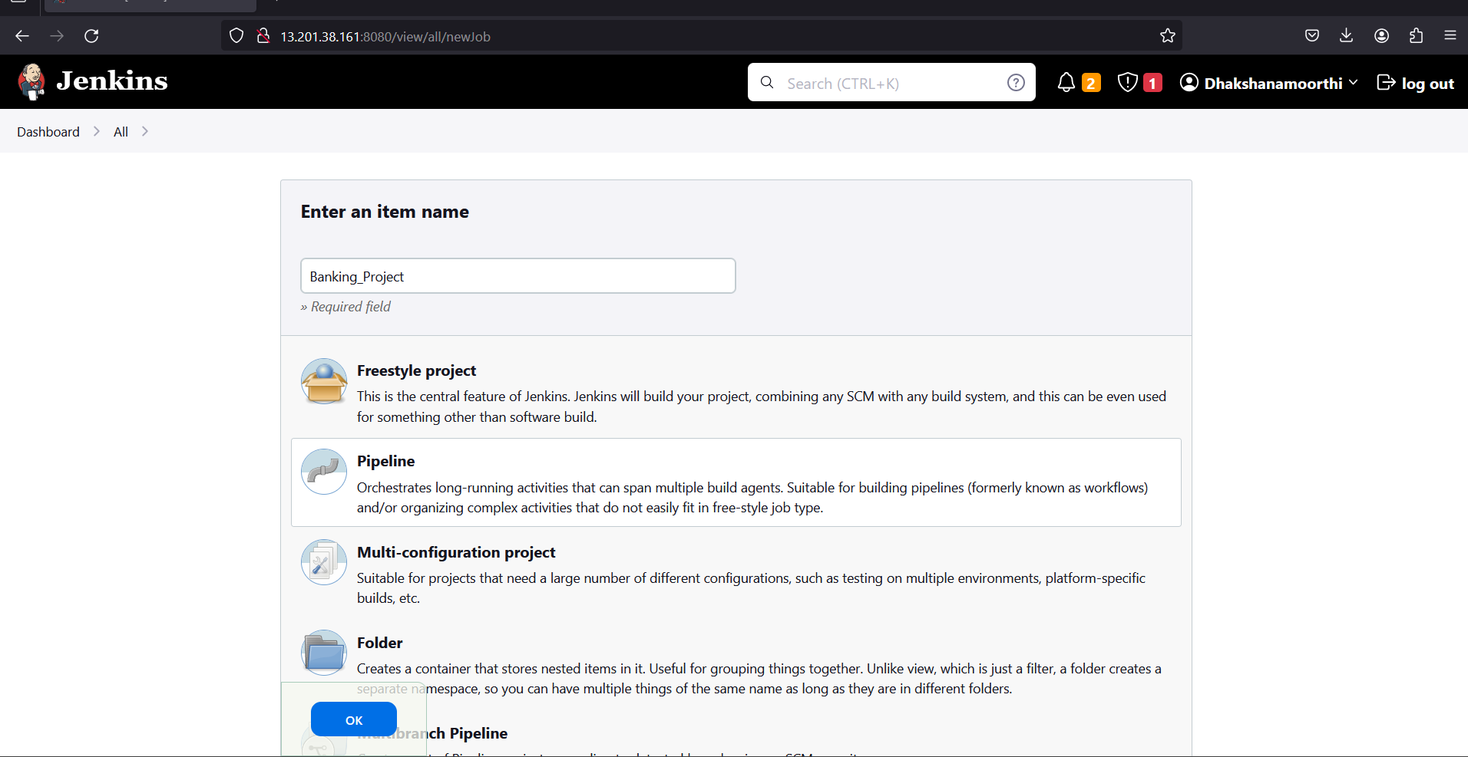

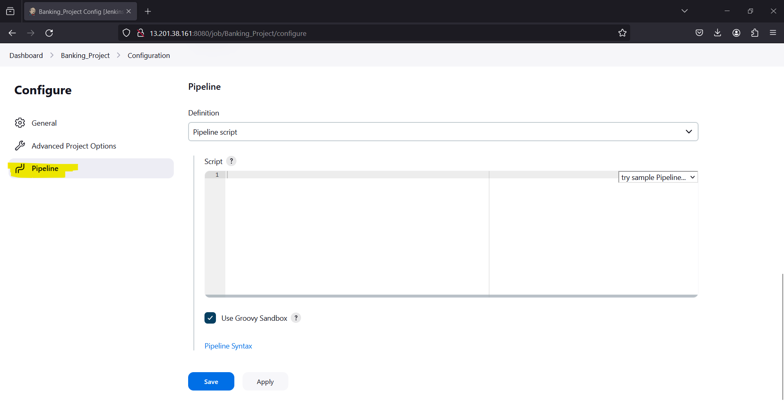

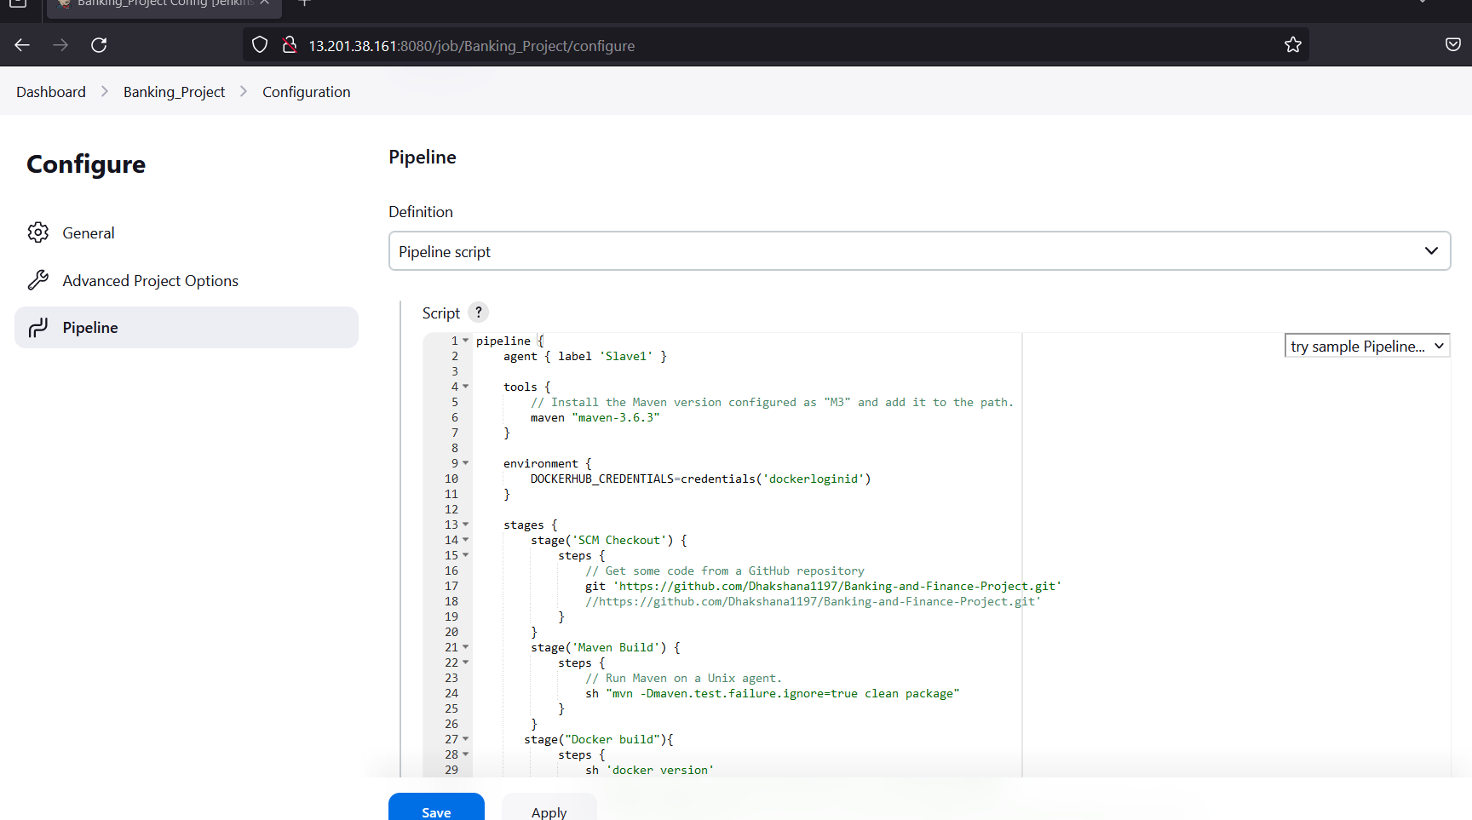

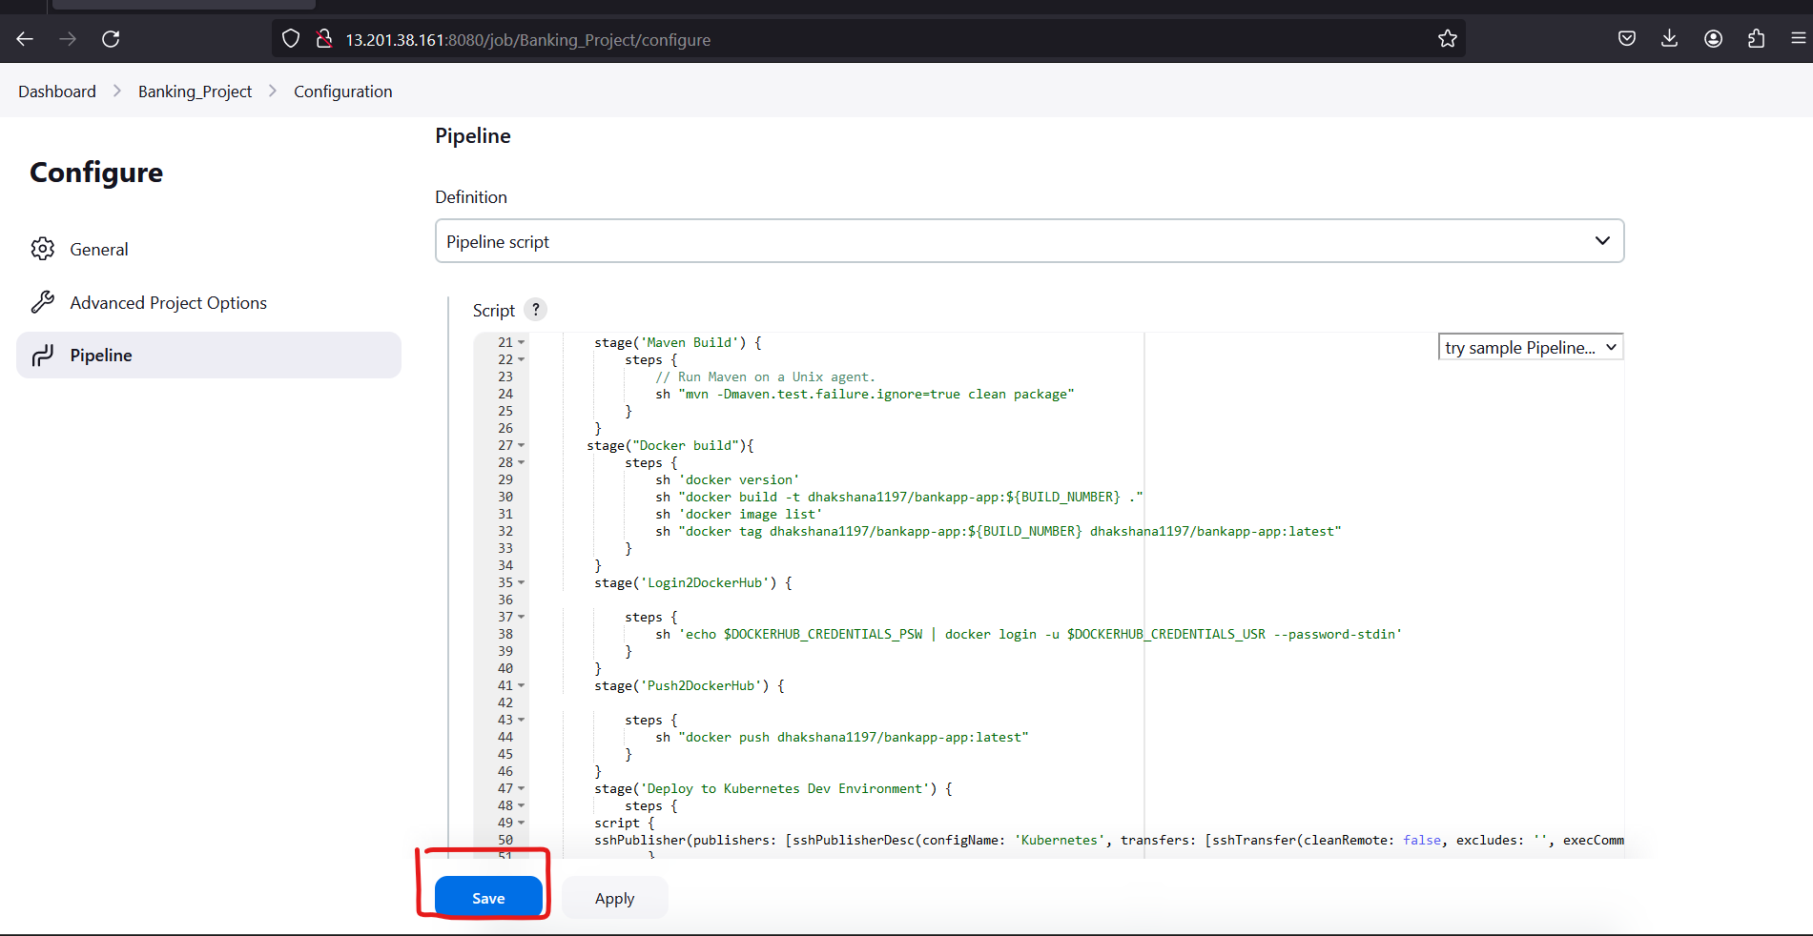

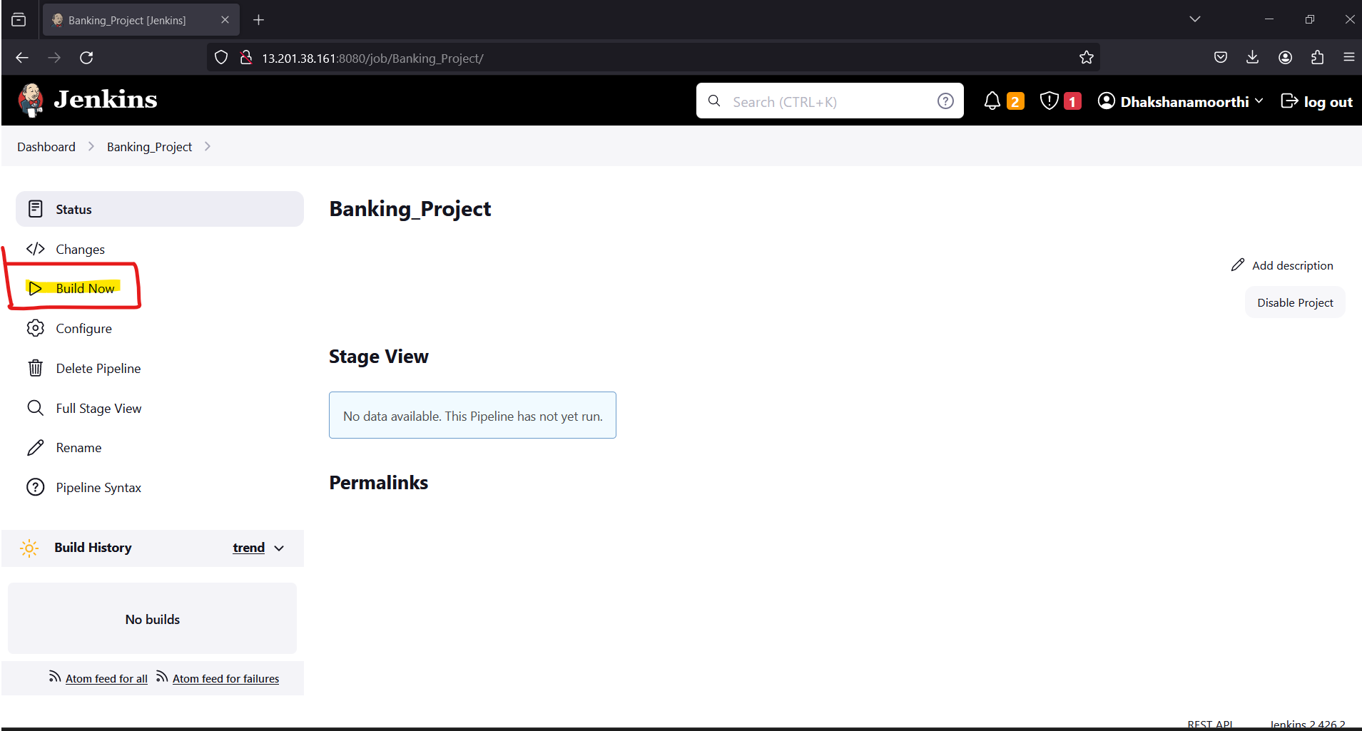

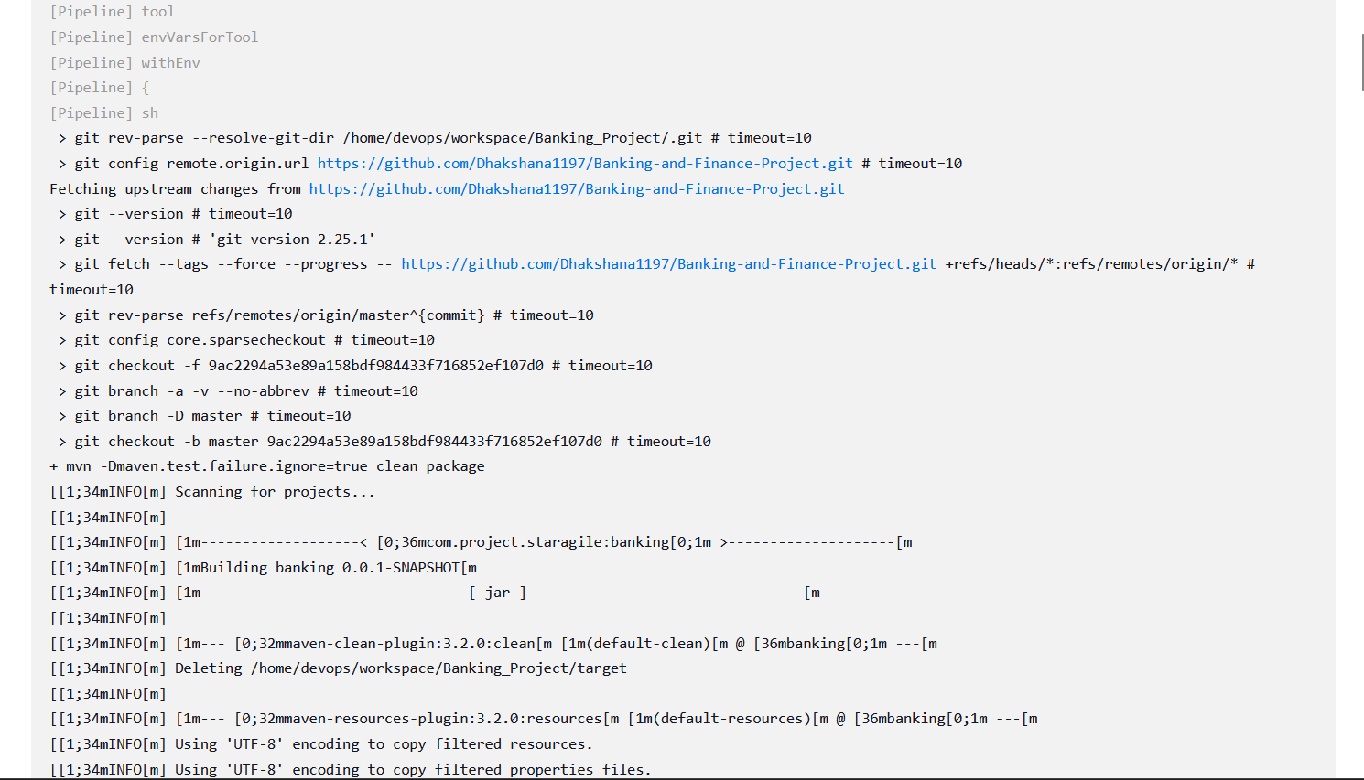

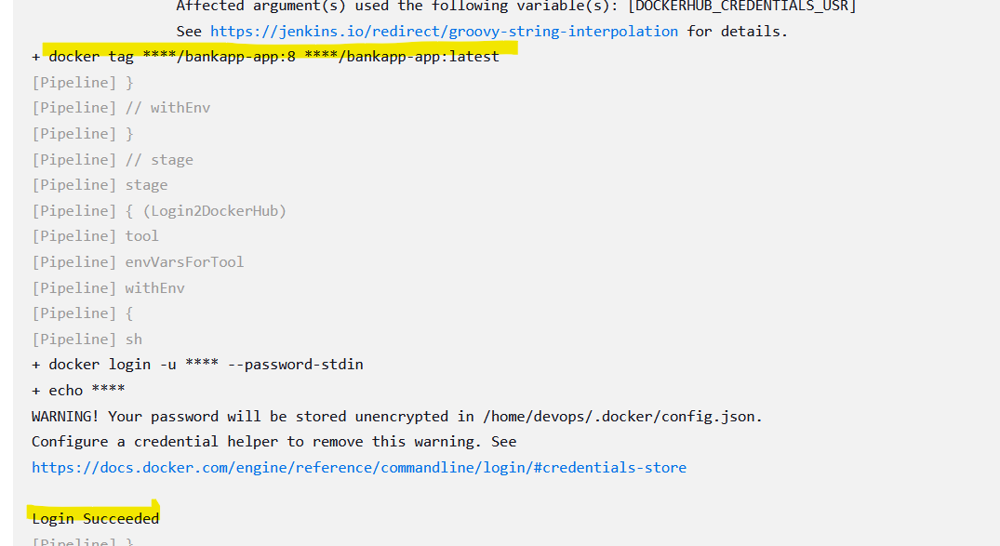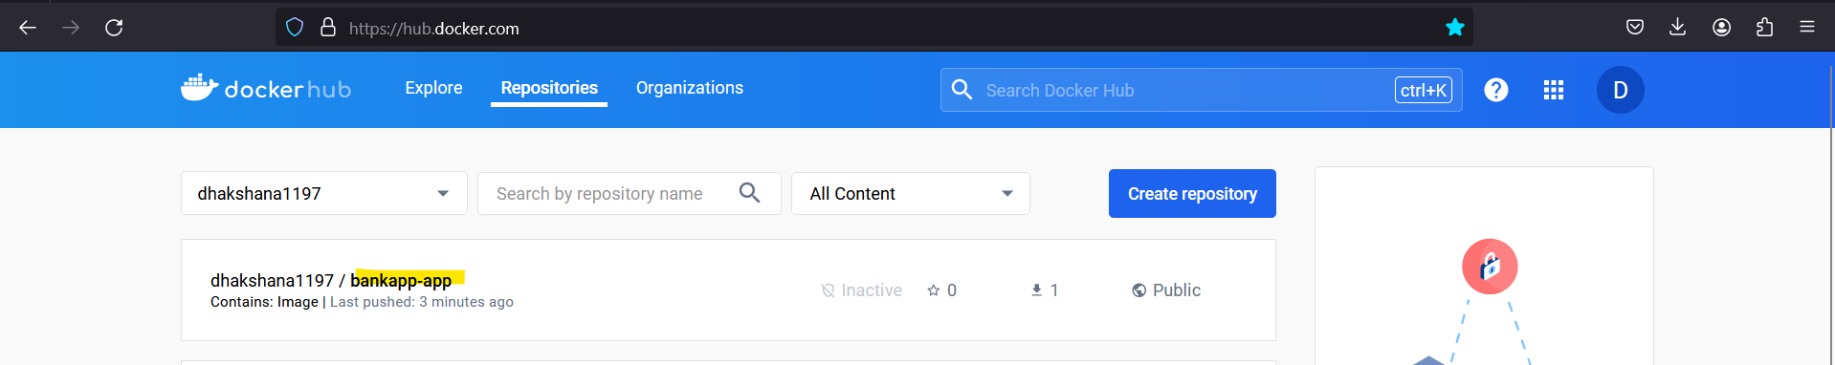

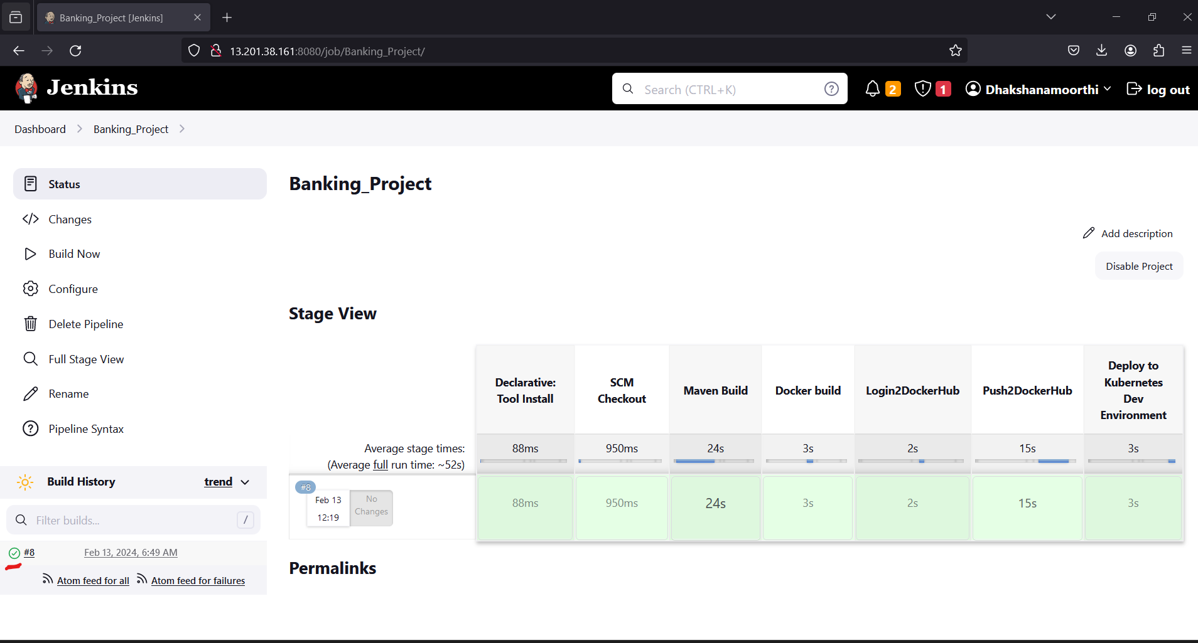

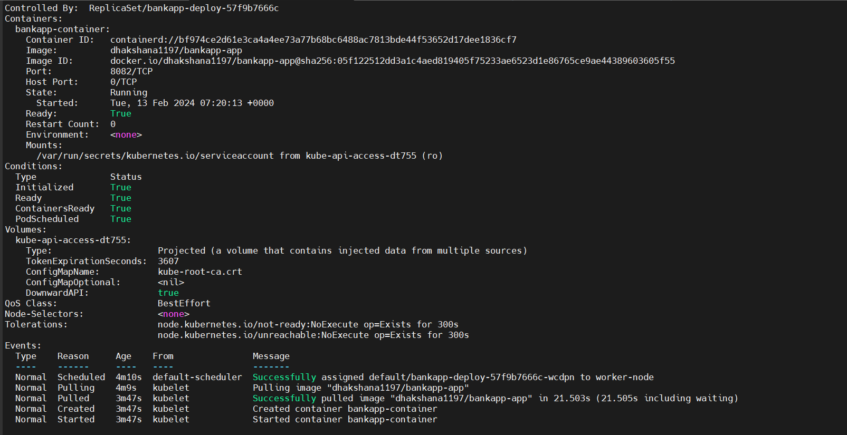**CHECK IN KUBERNETES MASTER .**

**KUBECTL GET SVC -o WIDE**  to check node port number



**ACCESS THROUGH BROWSER USING <public_ip>:<Node_PORT>**

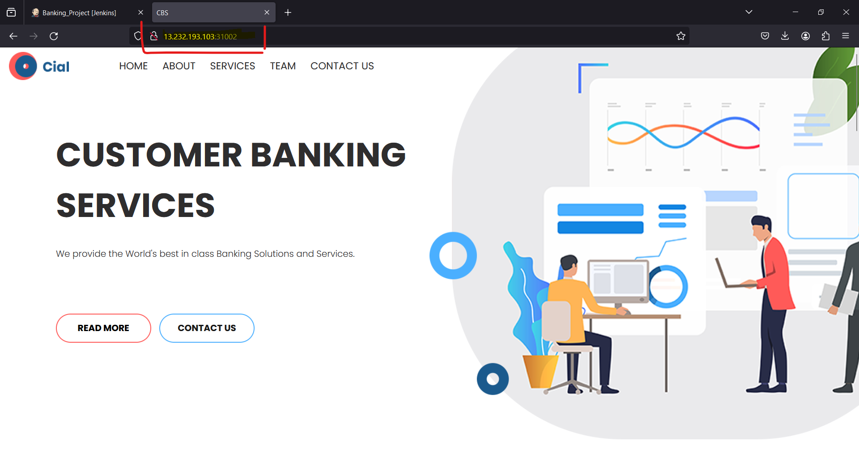

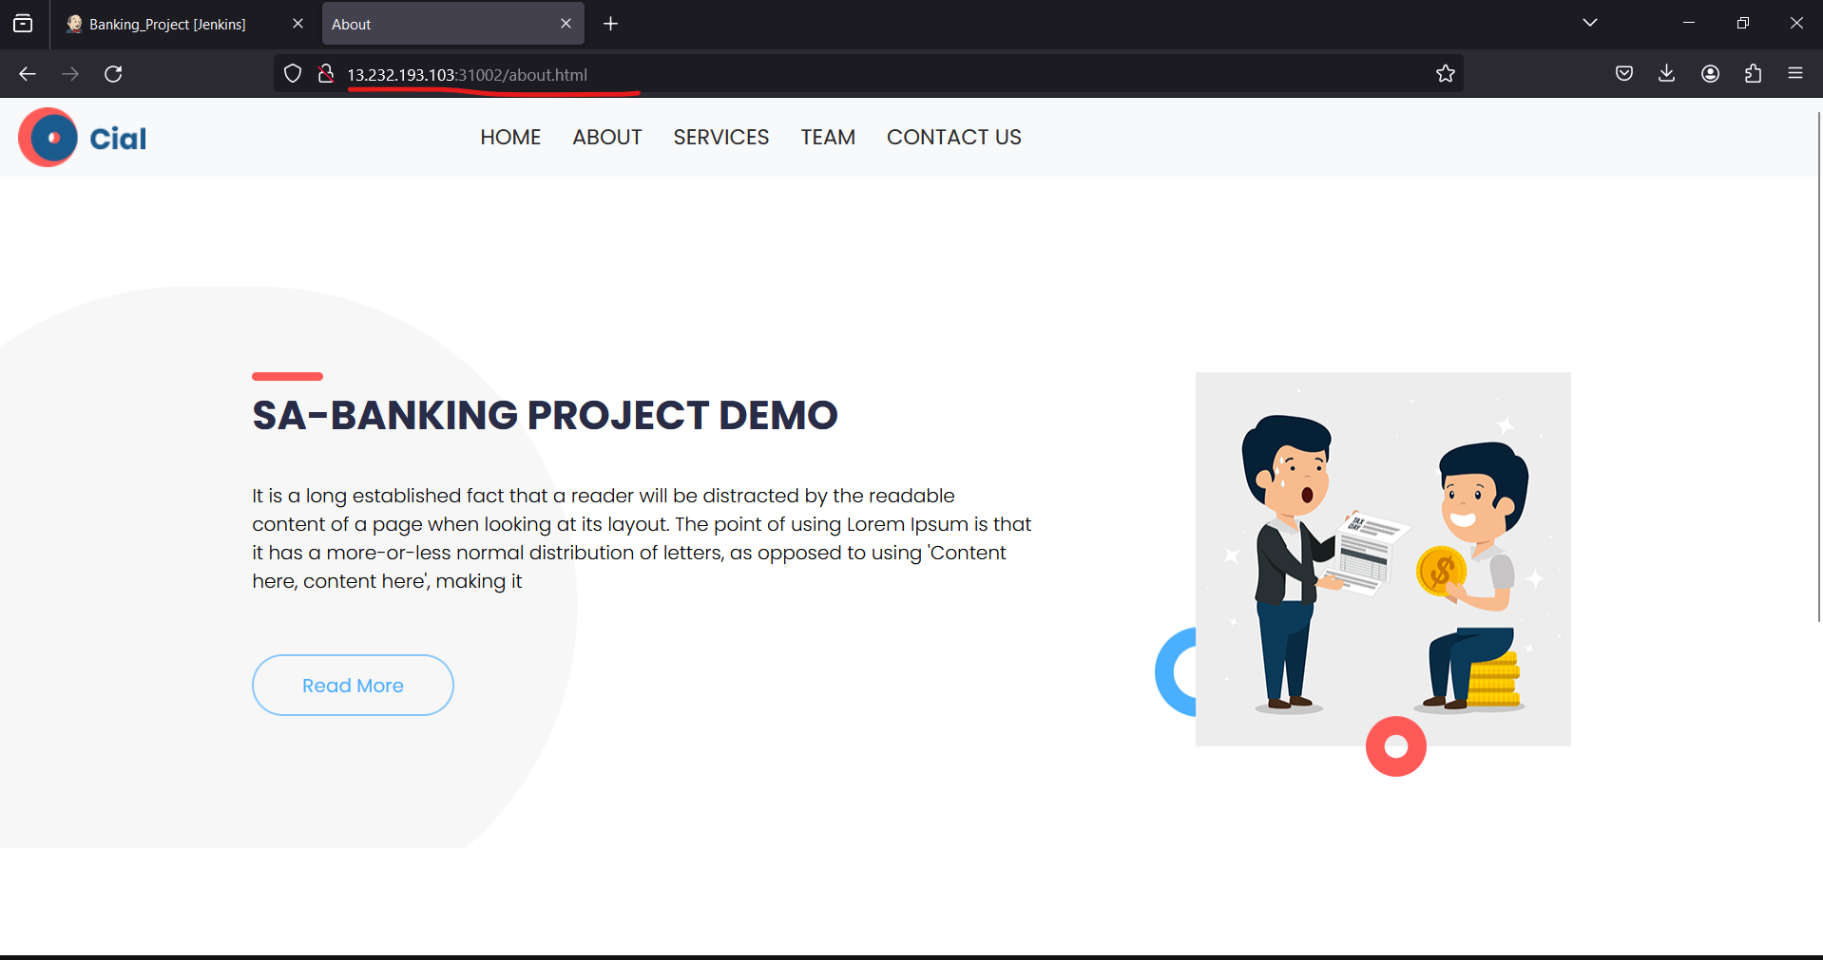

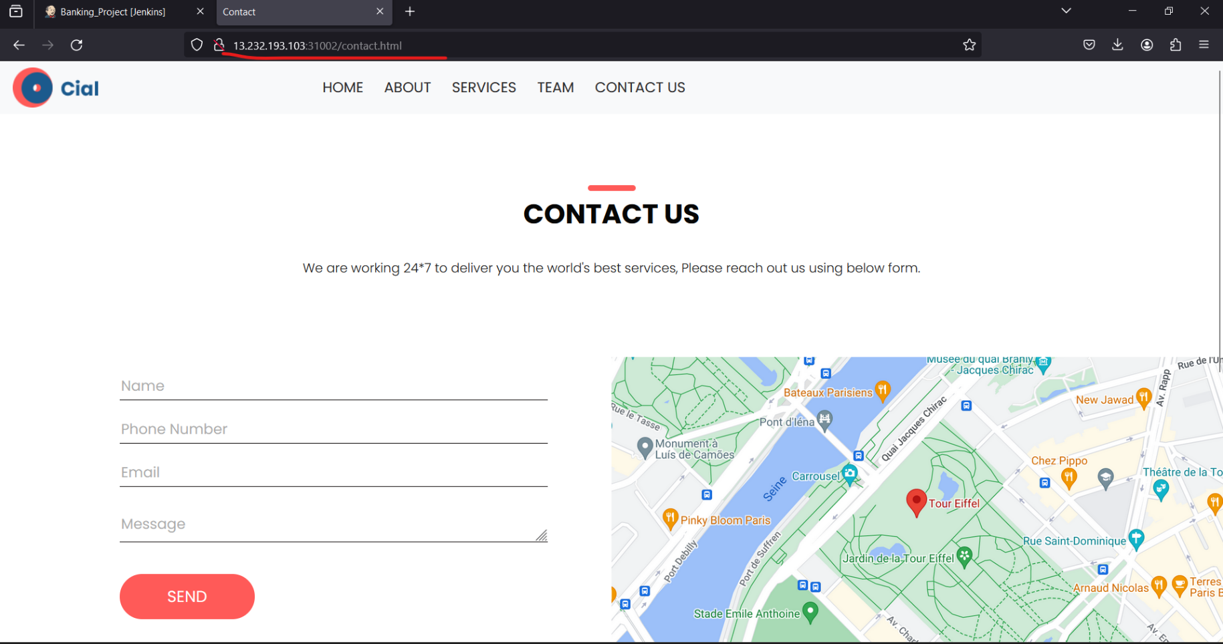

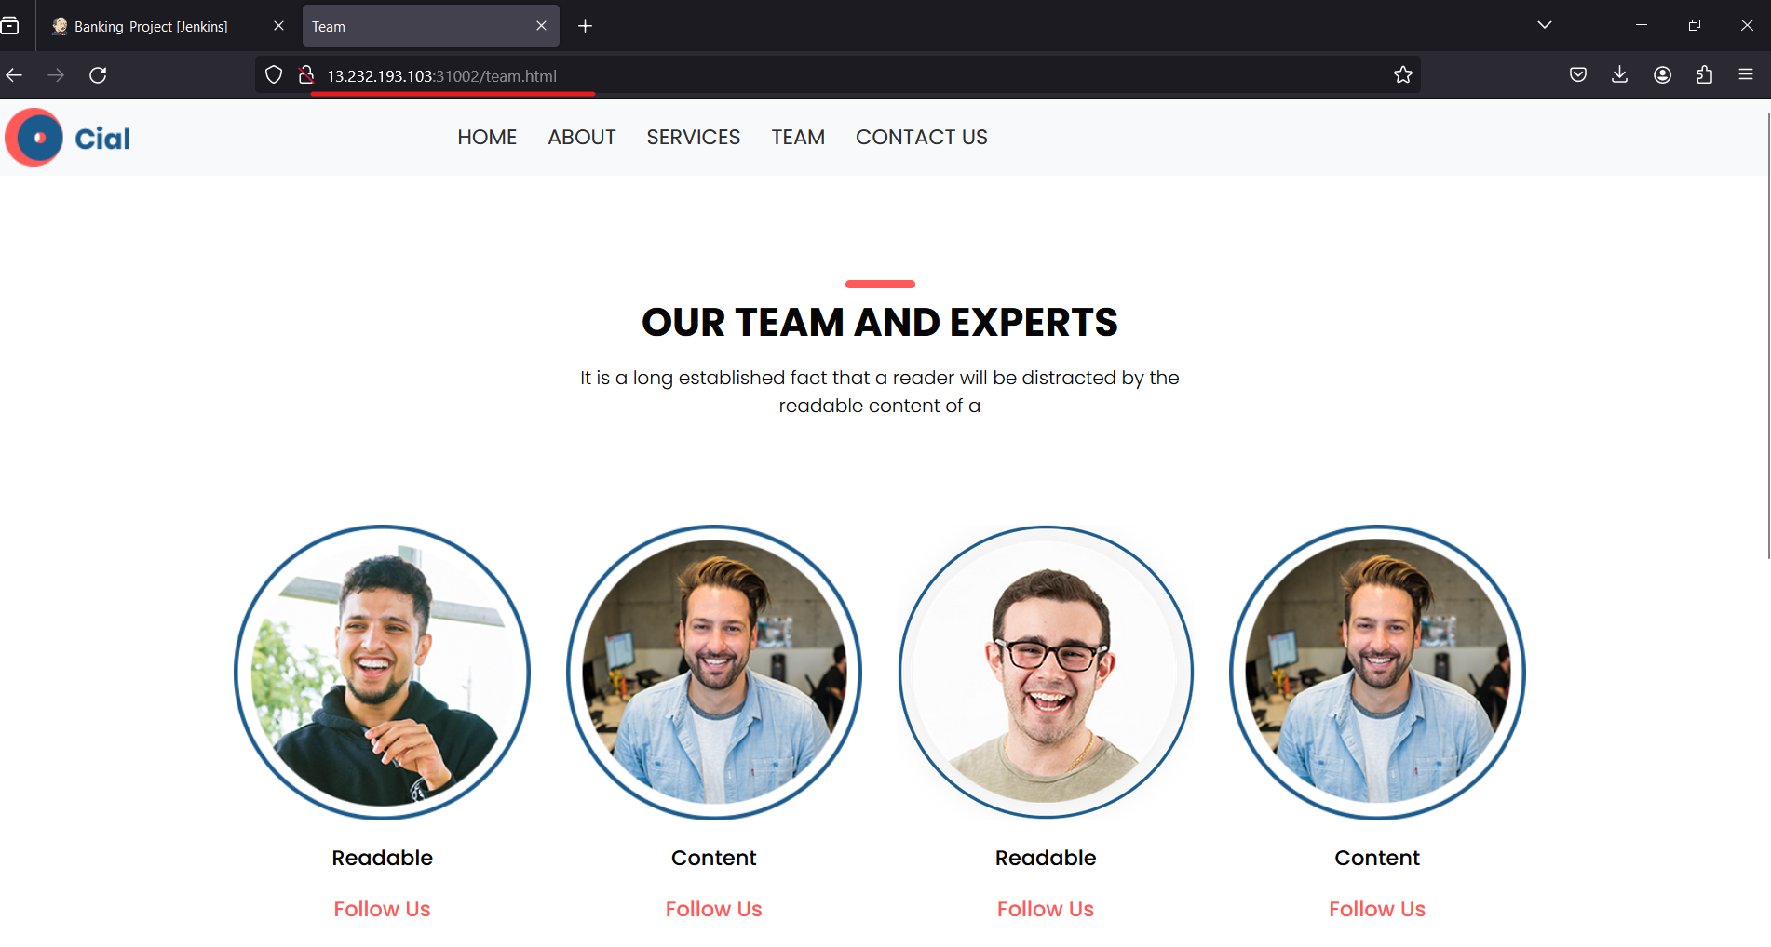

**NOW WE ARE GOING TO MONITOR SERVER TO MONITOR OUR APPLICATION.**

**<MONITOR_SERVER_ip>:9090**

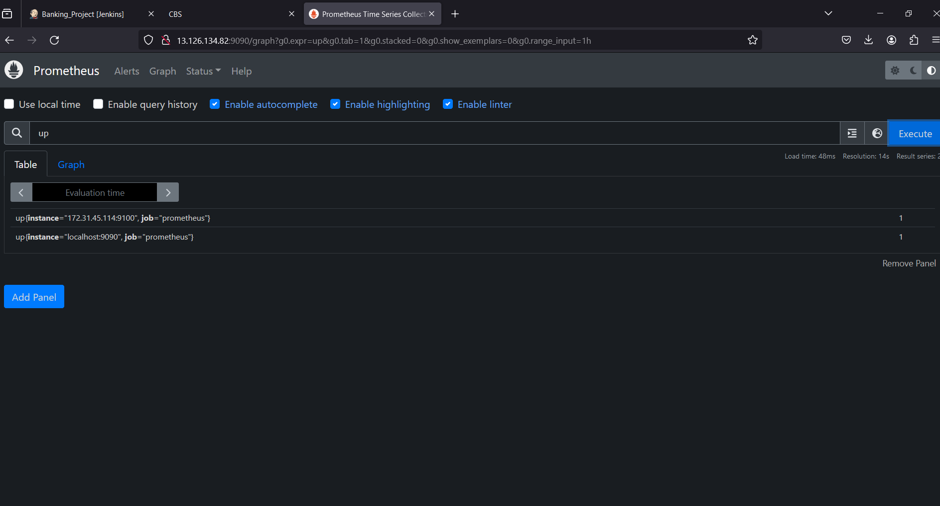

LOGIN TO GRAFFANA AND DATASOURCE AS PROMETHEUS AND ADD URL AND CREATE DASHBOARD

**<MONITOR_SERVER_IP>:3000**



